## **STT-LUT Implementation**

STT technology offers great advantages such as hardware reconfigurability and security when used in conjunction with lookup tables. For STT-LUT implementation, Magnetic Tunnel Junctions (MTJ) are utilized to store information that is used to determine the specific logic function of STT-LUT. Spin Transfer Torque or STT occurs inside the MTJs and is used to read, write and retain information in form of magnetic orientation**[“Darya Almasi”].** They consist of two ferromagnetic layers and an oxide barrier in between them; one layer has a fixed magnetic orientation which is referred to as fixed or pinned layer while the other is a free layer which magnetic orientation can be altered by changing the direction of the current passing through it. Depending on the layers’ orientation, they could have a state of logic “0” or a state of logic “1”. If the magnetic orientation of the two layers is in a parallel state with respect to each other (low resistance), then it holds a logic state of 0. Otherwise, if the magnetic orientation is in an antiparallel state (high resistance), it holds a logic state of 1. **[“Darya Almasi”].**

**Read and Write Operations**

In order to know the state of a MTJ or to switch the state of the MTJ, a current has to be applied. The applied current is different depending on the function that needs to be accomplished. If the desired function is to know the content of the cells(read operation), a relatively small current has to be applied to the MTJ. This current has to be smaller than the critical write current, which is the minimum current required to switch the state of an MTJ. The current will sense the resistance of the MTJ and the cell’s status as a state of 0(low resistance) or a state of 1(high resistance) will be read. On the other hand, if the desired function is to switch the state of the MTJ (write operation), then a current equal to or greater than the critical write current has to be applied. **[“Darya Almasi”].**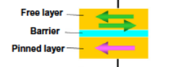

Figure 1 MTJ Composition[1]

Although the read operation is simple in theory, the write operation is more complex. To go from an anti parallel state to a parallel state, or write a 0 logic state to an MTJ, a current greater than the critical write current has to be applied. This current has to go from the free layer to the fixed layer, which means that electrons will flow from the fixed layer to the free layer. These electrons will apply a torque in the direction of the fixed magnetic field due to their spin polarization; some electrons will be reflected back towards the fixed layer, however, the amount of reflected electrons is minimal, so their spin will not have a detrimental effect on the orientation of the fixed layer. As a consequence of the torque applied by the spin-polarized electrons on the free layer, the magnetic orientation of the free layer will take the magnetic orientation of the fixed layer, effectively changing the state of the MTJ to a parallel state of low resistance. In contrast, to go from a parallel state to an anti parallel state, which is the same thing has writing a logic 1, a current has to be applied from the fixed layer to the free layer. In this case, electrons will flow from the free layer to the fixed layer, but the torque that the electrons applied on the fixed layer cannot switch the magnetic orientation of the fixed layer. A small percentage of electrons are reflected back to the free layer after taking an orientation opposite to the fixed layer. With a large enough current, the amount of reflected electrons will change the state of the free layer.

Figure 2: Physics behind Spin Transfer Torque[1]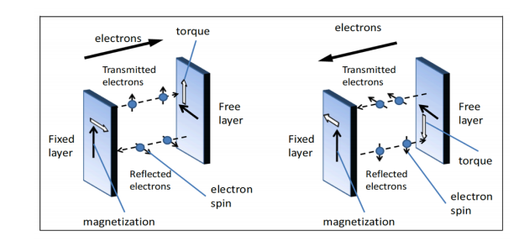

1. Bi, Y., et al., *Enhancing Hardware Security with Emerging Transistor Technologies*, in *Proceedings of the 26th edition on Great Lakes Symposium on VLSI*. 2016, ACM: Boston, Massachusetts, USA. p. 305-310.

[2]